**EX Coding Exercise (Thomas Ng, March 2016)**

**Assumption:**

1. The software calculates monthly payslip ONLY. It will not calculate payslip information of specific period (e.g. 5 March to 15 May).
2. The software will take input CSV file for employee salary and then output the payslip information in another CSV file. No UI is required as it is a backend software and the developer does not have enough Web UI knowledge at this moment. This is his first time to learn node.js and javascript.
3. The payslip calculator should be flexible to support the income tax rate in various years. (From 2009 afterward)
4. The software only support income tax rate from 2009. As there is no income tax rate for future year (2016 afterward), we will re-use the tax brackets from 2015 for the calculation for future year.
5. Each employee may have different superannuation rate contribution. We will not check the minimum compulsory super rate in this software as not outlined in the requirement. It will be enhanced in the future once the BA update the requirements.
6. The output Payslip CSV files will not sorted. It will be has the same order as the input CSV employee list.
7. If any validation error of input row of salary information csv file, it will display in the last column ‘error’ in the output csv file. The valid csv row will still be calculated and export to the output csv file.
8. Tests (not full tests as time limited) are provided and located at \test folder. It is using mocha. You can use this command to run all unit tests:

“npm test”

**Instruction to run the tests:**

npm test

**Instruction to run the application:**

To generate payslip for input csv file for financial year 2012, run this

node index.js [year] [inputCsvFile] [outputCsvFile]

**Example 1: to generate payslips for financial year 2012**

**node index.js 2012 ./input_files/salary2012.csv ./output_files/result2012.csv**

**or using the batch file.**

**Run.bat**

**Example 2: to generate payslips for financial year 2012 and some input csv records has error**

**node index.js 2012 ./input_files/invalidsalary2012.csv ./output_files/result2012_error.csv**

**or using the batch file.**

**run_error_sample.bat**

**Example 3: to generate 5000 payslips for financial year 2014 (Executed Time : 1740 msec)**

**node index.js 2014 ./input_files/salaryLarge.csv ./output_files/resultLarge.csv**

**or using the batch file.**

**run_5000_payslip**

**Source Code Structure and Design**

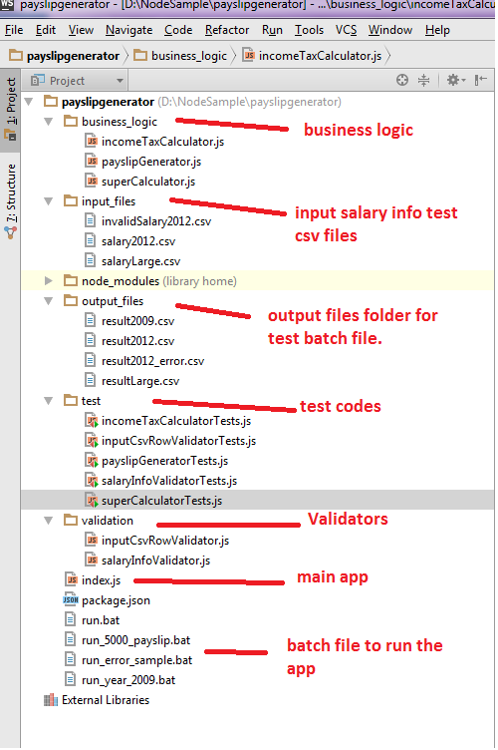

|  |  |  |
| --- | --- | --- |
| Main source files | Description | Folder |
| Index.js | App main entry point   * Read csv input file * Generate payslips * Output to CSV file | root |
| inputCsvRowValidator.js | Validate the CSV row record from input file before generating payslip. | validation |
| payslipGenerator.js | Take a salaryInfo object and generate the corresponding payslip. | business_logic |
| salayInfoValidator.js | Validate the salaryInfo (transformed from csv input record) before payslip generation. | validation |
| incomeTaxCalculator.js | Calculate the income tax based on financial year and annual salary. | business_logic |
| superCalculator.js | Calculate the super amount | business_logic |
|  |  |  |
|  |  |  |

|  |  |  |
| --- | --- | --- |
| Test files | Description | Folder |
| incomeTaxCalculatorTests.js | Tests for incomeTaxCalculator | test |
| superCalculatorTests.js | Tests for superCalculator | test |
| payslipGeneratorTests.js | Tests for payslipGenerator | test |
| inputCsvRowValidatorTests.js | Tests for inputCsvRowValidator | test |
| salaryInfoValidatorTests.js | Tests for salaryInfoValidator | test |
|  |  |  |
|  |  |  |

|  |  |  |
| --- | --- | --- |
| Run batch files | Description | Folder |
| run.bat | Generate the sample (in the spec) payslips in 2012 | root |
| run_5000_Payslip.bat | Generate 5000 payslips in 2014 | test |
| run_error_sample.bat | Generate payslips but some input salary info has validation error. | test |
| run_year_2009.bat | Generate the sample payslips in year 2009. You will expect the employee paid different income tax as different tax rate. | test |
|  |  |  |
|  |  |  |
| All sample input salary info input files | | input_files |
| All output payslips csv files | | output_files |